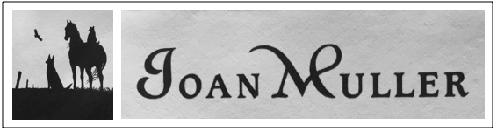

161 New Sweden Rd.
Woodstock, CT 06281
860-428-1563
wyndwords@gmail.com

Emergency Contact Information

Name of student________________________________________________________
Parent/guardian name__________________________________________________
Daytime phone #_____________________________Cell_______________________
Other contact #_________________________________________________________

I hereby grant Joan Muller my consent for the administration of any emergency treatment deemed necessary in the event my child becomes ill or injured while attending art classes. Joan Muller will make every attempt to contact the parent(s) as quickly as possible.

List facts concerning the child’s medical history (medications being taken, allergies, physical limitations, etc.) to which Joan Muller or medical persons should be alerted
__________________________________________________________________________________________________________
___________________________________________________________________________________________________________
___________________________________________________________________________________________________________
Date_______________________Parent/guardian signature________________________________________________

REFUSAL TO CONSENT FOR MEDICAL EMERGENCY TREATMENT
I do not give me consent to Joan Muller for emergency medical treatment of my child. In the event of illness or injury requiring emergency treatment, I wish Joan Muller to take no action other than to contact the parent/guardian.
Date______________________Parent/guardian_____________________________________________________________

AUTHORIZED PICK UP LIST
Please list any adult who is authorized to drop off or pick up your child from art classes. This list should include anyone who would be able to leave with the child.
Name_______________________________________________________________phone/cell_________________________
Name_______________________________________________________________phone/cell_________________________
Name_______________________________________________________________phone/cell_________________________

Photography of art: Joan Muller may take pictures of a child’s artwork which could include the child, but all children’s faces will be cropped out of photographic images. Rest assured that no images of any child nor a child’s name will be displayed to the public.

